DBS311A Lab 5

1.

create or replace PROCEDURE Even_Odd(v_value1 NUMBER)

IS

division NUMBER := 0;

BEGIN

division := MOD(v_value1, 2);

IF division = 0

THEN DBMS_OUTPUT.PUT_LINE ('The number '|| v_value1 ||' is even');

ELSE

DBMS_OUTPUT.PUT_LINE ('The number '|| v_value1 ||' is odd');

END IF;

END Even_Odd;

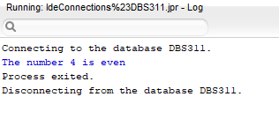 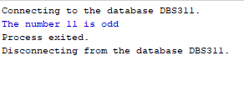

2.

create or replace PROCEDURE FIND_EMPLOYEE(p_empid NUMBER)

IS

firstName employees.first_name%TYPE;

lastName employees.last_name%TYPE;

email employees.email%TYPE;

phone employees.phone%TYPE;

hireDate VARCHAR2(255 BYTE);

jobTitle employees.job_title%TYPE;

BEGIN

SELECT first_Name, last_Name, email, phone, TO_CHAR(hire_date, 'DD-MON-YY'), job_title

INTO firstName, lastName, email, phone, hireDate, jobTitle

FROM employees WHERE employee_id = p_empid;

DBMS_OUTPUT.PUT_LINE('First Name: '||firstname);

DBMS_OUTPUT.PUT_LINE('Last Name: ' || lastName);

DBMS_OUTPUT.PUT_LINE('Email: '||email);

DBMS_OUTPUT.PUT_LINE('Phone: '||phone);

DBMS_OUTPUT.PUT_LINE('Hire date: '||hireDate);

DBMS_OUTPUT.PUT_LINE('Job Title: '||jobTitle);

EXCEPTION

WHEN NO_DATA_FOUND THEN

DBMS_OUTPUT.PUT_LINE ('Valid Id');

WHEN OTHERS THEN

DBMS_OUTPUT.PUT_LINE('SOME ERROR HAPPENED');

END FIND_EMPLOYEE;

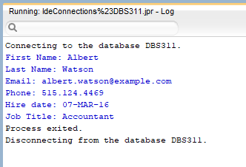 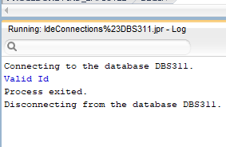

3.

create or replace PROCEDURE UPDATE_PRICE_BY_CAT (p_catid IN NUMBER, p_amount IN NUMBER)

IS

Rows_updated NUMBER;

BEGIN

UPDATE PRODUCTS

SET list_price = list_price + p_amount

WHERE category_id=p_catid AND list_price > 0;

Rows_updated := sql%rowcount;

IF rows_updated=0

THEN DBMS_OUTPUT.PUT_LINE ('Invalid CatId');

ELSE

DBMS_OUTPUT.PUT_LINE (rows_updated ||' rows updated');

END IF;

ROLLBACK;

END UPDATE_PRICE_BY_CAT;

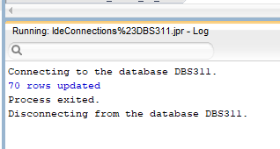 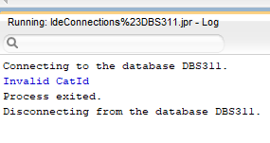

4.

create or replace PROCEDURE UPDATE_PRICE_UNDER_AVG

IS

avgPrice products.list_price%TYPE;

Rows_updated NUMBER;

BEGIN

SELECT AVG(list_price) INTO avgPrice FROM products;

IF avgPrice <=1000

THEN

UPDATE Products SET list_price = list_price * 1.02 WHERE list_price < avgPrice;

ELSE

UPDATE Products SET list_price = list_price * 1.01 WHERE list_price < avgPrice;

END IF;

Rows_updated := sql%rowcount;

DBMS_OUTPUT.PUT_LINE (rows_updated ||' rows updated');

ROLLBACK;

EXCEPTION

WHEN OTHERS THEN

DBMS_OUTPUT.PUT_LINE('SOME ERROR HAPPENED');

END UPDATE_PRICE_UNDER_AVG;

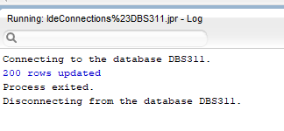

5.

create or replace PROCEDURE PRODUCT_PRICE_REPORT

IS

cheap_count NUMBER;

fair_count NUMBER;

exp_count NUMBER;

avg_price products.list_price%TYPE;

min_price products.list_price%TYPE;

max_price products.list_price%TYPE;

BEGIN

DBMS_OUTPUT.PUT_LINE ('Category 1');

SELECT AVG(list_price), MIN(list_price), MAX(list_price) INTO avg_price, min_price, max_price FROM products WHERE category_id = 1;

SELECT COUNT(*) INTO cheap_count FROM products WHERE list_price < ((avg_price - min_price) / 2) AND category_id=1;

SELECT COUNT(*) INTO exp_count FROM products WHERE list_price > ((max_price - avg_price) / 2) AND category_id=1;

SELECT COUNT(*) INTO fair_count FROM products WHERE (list_price > (avg_price - min_price) / 2) AND list_price < ((max_price - avg_price) / 2) AND category_id=1;

DBMS_OUTPUT.PUT_LINE ('Cheap: '|| cheap_count);

DBMS_OUTPUT.PUT_LINE ('Fair: '|| fair_count);

DBMS_OUTPUT.PUT_LINE ('Expensive: '|| exp_count);

DBMS_OUTPUT.PUT_LINE ('Category 4');

SELECT AVG(list_price), MIN(list_price), MAX(list_price) INTO avg_price, min_price, max_price FROM products WHERE category_id = 4;

SELECT COUNT(*) INTO cheap_count FROM products WHERE list_price < ((avg_price - min_price) / 2) AND category_id=4;

SELECT COUNT(*) INTO exp_count FROM products WHERE list_price > ((max_price - avg_price) / 2) AND category_id=4;

SELECT COUNT(*) INTO fair_count FROM products WHERE (list_price > (avg_price - min_price) / 2) AND list_price < ((max_price - avg_price) / 2) AND category_id=4;

DBMS_OUTPUT.PUT_LINE ('Cheap: '|| cheap_count);

DBMS_OUTPUT.PUT_LINE ('Fair: '|| fair_count);

DBMS_OUTPUT.PUT_LINE ('Expensive: '|| exp_count);

DBMS_OUTPUT.PUT_LINE ('Category 5');

SELECT AVG(list_price), MIN(list_price), MAX(list_price) INTO avg_price, min_price, max_price FROM products WHERE category_id = 5;

SELECT COUNT(*) INTO cheap_count FROM products WHERE list_price < ((avg_price - min_price) / 2) AND category_id=5;

SELECT COUNT(*) INTO exp_count FROM products WHERE list_price > ((max_price - avg_price) / 2) AND category_id=5;

SELECT COUNT(*) INTO fair_count FROM products WHERE (list_price > (avg_price - min_price) / 2) AND list_price < ((max_price - avg_price) / 2) AND category_id=5;

DBMS_OUTPUT.PUT_LINE ('Cheap: '|| cheap_count);

DBMS_OUTPUT.PUT_LINE ('Fair: '|| fair_count);

DBMS_OUTPUT.PUT_LINE ('Expensive: '|| exp_count);

EXCEPTION

WHEN OTHERS THEN

DBMS_OUTPUT.PUT_LINE('SOME ERROR HAPPENED');

END PRODUCT_PRICE_REPORT;

